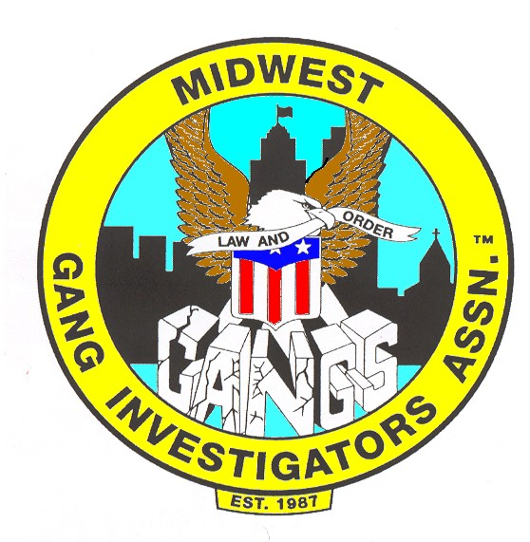  INDIANA OFFICERS  President  Chris Sallows  Steuben Co. Probation Dept.  205 S. Martha St.  Suite 201  Angola, IN 46703  (260) 668-1000 Ext. 3000  csallows@co.steuben.in.us  Vice President  Kyle Dombrowksi  South Bend Police Department  701 W. Sample St.  South Bend, IN 46601  574-235-9201  kdombrow@southbendin.gov  Treasurer  Carl Conway  Elkhart Police Department  175 Waterfall Drive  Elkhart, IN 46516  574-295-7070  carl.conway@elkhartpolice.org  Secretary  Pat Reardon  Steuben Co. Sheriff’s Dept.  206 E. Gale  Angola, IN 46703  260-668-1000 Ext. 5000  preardon@co.steuben.in.us | Dakotas * Kentucky * Illinois * Indiana * Iowa * Michigan  Minnesota * Missouri * Nebraska * Ohio * Wisconsin  The Midwest Gang Investigators Association  Indiana Chapter  P.O. Box 284  Angola, IN 46703  MGIA INDIANA CHAPTER  2019 Gang Trends & Updates  November 6th, 2019  Hosted by Indiana Chapter of MGIA  In conjunction with the Indiana State Police (ISP), Indiana Department of Corrections (IDOC), and the Indianapolis Metro Police Department (IMPD).  LOCATION: Monroe Convention Center  ADDRESS: 302 South College Avenue, Bloomington, IN 47403  8-hours of ILEA training credit w/ certificate is given upon class completion.  Lunch is on your own. Refreshments will be on-site.  ^{TRAINING SCHEDULE}  Registration: Starts at 7:30am | Class starts at 8:00am & ends at 5:00pm  8:00am – 9:30am: Indiana State Police Gang Survey  Stacey Gosnell-Day (Analyst – Indiana State Police)  10:00am – 12:00pm: Gangs in Indianapolis & Southern Indiana  David Miller (Sergeant Indy Metro PD / FBI HIDTA Safe Streets Task Force)  *** 12:00pm – 1:00pm: Lunch on your own ***  1:00pm – 5:00pm: Prison Gang Updates & Gangs 101  Kurt Bensheimer (Deputy Chief – Indiana Dept. of Corrections)
INDIANA OFFICERS  President  Chris Sallows  Steuben Co. Probation Dept.  205 S. Martha St.  Suite 201  Angola, IN 46703  (260) 668-1000 Ext. 3000  csallows@co.steuben.in.us  Vice President  Kyle Dombrowksi  South Bend Police Department  701 W. Sample St.  South Bend, IN 46601  574-235-9201  kdombrow@southbendin.gov  Treasurer  Carl Conway  Elkhart Police Department  175 Waterfall Drive  Elkhart, IN 46516  574-295-7070  carl.conway@elkhartpolice.org  Secretary  Pat Reardon  Steuben Co. Sheriff’s Dept.  206 E. Gale  Angola, IN 46703  260-668-1000 Ext. 5000  preardon@co.steuben.in.us | REGISTRATION FORM  Cost: FREE for MGIA members.  ***Payment of $25.00 for Non-MGIA Members***  Please complete the below registration form and email or mail to Secretary Pat Reardon.  Payments (cash, check, M/O, CC, invoice) will need to be sent to the below address. Payments can also be made day of the training. Any questions, please feel free to ask any of the MGIA Indiana Board Members.  MGIA – Indiana Chapter  P.O. Box 284  Angola, Indiana 46703  Attn: Sec. Pat Reardon  Email: preardon@co.steuben.in.us  Training Certificate for 8-hours of ILEA training credit will be emailed after the training is completed.  HOTEL INFORMATION  Lodging is available at the Courtyard by Marriott (connected to the convention center)  310 S. College Ave., Bloomington, IN | 855-269-7719  https://www.reservations.com/hotel/courtyard-by-marriott-bloomington
INDIANA OFFICERS  President  Chris Sallows  Steuben Co. Probation Dept.  205 S. Martha St.  Suite 201  Angola, IN 46703  (260) 668-1000 Ext. 3000  csallows@co.steuben.in.us  Vice President  Kyle Dombrowksi  South Bend Police Department  701 W. Sample St.  South Bend, IN 46601  574-235-9201  kdombrow@southbendin.gov  Treasurer  Carl Conway  Elkhart Police Department  175 Waterfall Drive  Elkhart, IN 46516  574-295-7070  carl.conway@elkhartpolice.org  Secretary  Pat Reardon  Steuben Co. Sheriff’s Dept.  206 E. Gale  Angola, IN 46703  260-668-1000 Ext. 5000  preardon@co.steuben.in.us | 2019 Gang Trends & Updates  ^{November 6th, 2019}  ^{Name:}  ^{Title/Rank:}  ^{Agency:}  ^{Address:}  ^{City:}  ^{State/Zip:}  ^{Phone:}  ^{Email:}  Check One: __Law Enforcement __Corrections __Probation/Parole __Prosecutor  Check One: __MGIA Member __Non-Member

